**CW Machine Window**

# Geoff Anderson G3NPA, Hew Lines VA7HU, Aki Yoshida JA1NLX and Orrin Delany WO4D

### 2.1.7 Slow Typing Options

From Ver. 3.1.2 of the CW Machine, the Slow Typing option has a different function. With the Slow Typing option checked, the keyer does not automatically revert to receive when the buffer is sent. The keyer can be forced to receive (PTT turned off) by clicking Abort, typing the <**Esc**> key, or executing the $receive$ macro.

**Note**: the object of the Slow Typing option is to prevent the radio PTT going on/off as slow typists pecked their way through a message.  Unless a user has a specific need for the slow typing option, it is STRONGLY RECOMMENDED THIS OPTION BE TURNED OFF.

### 2.1.8 Keyer Setup - WinKey

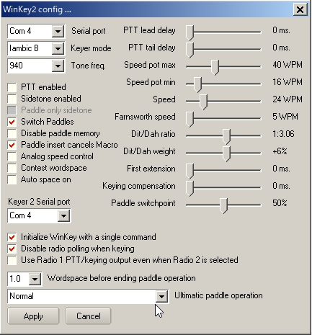

new CWM_10

Added Radio 2 serial port to the CW Machine WinKey and WinKey2 setup (ver3.50). In the case of WinKey2 it supports 2 CW output for Radio1 and Radio2. You must specify same serial port. in the Keyer 2 serial port box.

Full information on all of these settings can be obtained from the WinKey Interface manual downloadable from <http://k1el.tripod.com/docs.html>. Most of these settings can simply be left alone until you know what effect they will have. There are, however, one or two where a little extra information might help.

**Analog Speed Control** - Check this item if you wish to have control of the keying speed via the external control. Unchecked and Logger32 will be able to change the keying speed using a right-click on the speed indicator.

**Key On n (where n is 3 or 5)** - The default is pin 3 for the keying. Select pin 5 if this is your preference. Note for MicroKey users: It is recommended that you use pin 3 keying. If you select pin 5 then the PTT will key instead.

**Sidetone** - You are strongly advised to read the WinKey information about the use of sidetone - for this is related to the keying pin in use at the time. MicroKeyer users do NOT need the sidetone activated here. In this case it is better to use the sidetone switch in the USB device router (CW/WinKey tab).

**Initialize Winkey with a single command** - Check this option if you want to initialize the WinKey with a single command (this is the default setting). Or, uncheck this option if you want to initialize the WinKey with one parameter at a time (there's 15 of them). This option is for users of RemoteRig.

**Use Radio 1 PTT/keying output even when Radio 2 is selected ~~Key Radio 1 from pin 3, Radio 2 from pin 5~~** ~~–~~ Uncheck this option if you want ~~This provides for~~ an automatic change of the CW keying line from pin 3 to pin 5 when the radio is changed from Radio 1 to Radio 2. See the SO2R section for more details.

**Disable Radio Polling when keying** - Some radios seem to prefer that the polling cease when transmitting. This gives the user the ability to select that option.

**Notes for users of MicroKeyer -** When Logger32 opens the WinKey serial port then Logger32 takes control over ALL of WinKey including PTT on pin 5. If you do not want PTT generation from WinKey when Logger32 is running you must uncheck the PTT checkbox in Logger32. Logger32 ALWAYS has priority. WinKey pin 5 is multifunctional. Logger32 can use this pin for the following functions:

* + None;
  + PTT;
  + Sidetone; or
  + Second CW output.

MicroKeyer allows only "None" and "PTT", but Logger32 can control all functions. Inside the MicroKeyer is a jumper called SO1R/SO2R. It's a jumper for pin 5. If it is in the SO1R position then pin 5 is used for PTT. If in the SO2R position then pin 5 is disconnected from the PTT circuits and wired to the REMOTE mini DIN 6 connector (signal will be used in SO2R extension for MicroKeyer as second CW source).

### 2.1.9 Assign Insert Key

From this menu you can assign any of the preset shortcut keys to the <**INS**> key, <**SPACE**> key or <**ENTER**> key on the keyboard.